ANALYTICS ON 5000 ENTRY DATA SET

WRITTEN BY : JIMOH-AKINDELE MUTIU
COURSE : HIGHER DIPLOMA IN SCIENCE IN DATA ANALYTICS
STUDENT NO : 10276658
MODULE : PROGRAMMING FOR BIG DATA
LECTURER : DARREN REDMOND

The dataset used for this Continuos Assessment contains over 5,000 lines of texts. In order to carry out any form of analysis on the dataset, it was cleaned and transformed into a csv file placed in a relevant holder using a powerful programming language called Python. It was observed that the csv file contains 422 different set of commit objects. The csv file was stored and named changes.csv.
In other to analyze this dataset, Tableau which is a powerful Business Intelligence and Analytics tool was used. Tableau is in the leaders quadrant on Gartner’s Magic Quadrant for Business Intelligence and Analytics platform. It offers a highly interactive visual based exploration experience for users to easily access, prepare and analyze data without the need for coding.
The dataset (changes.csv) was loaded into tableau for analysis. It could be seen that the data set contains three columns (headers) namely Revision, Author and Date. Using Custom Split in Tableau, the Date column was splitted into three additional columns namely Day, Month and Year. This was done to enable me carry out further analysis the number of commits each Author made in a particular day, month or year. See below for details of the analysis carried out on the dataset:-

1. Below shows the dataset in Tabeau

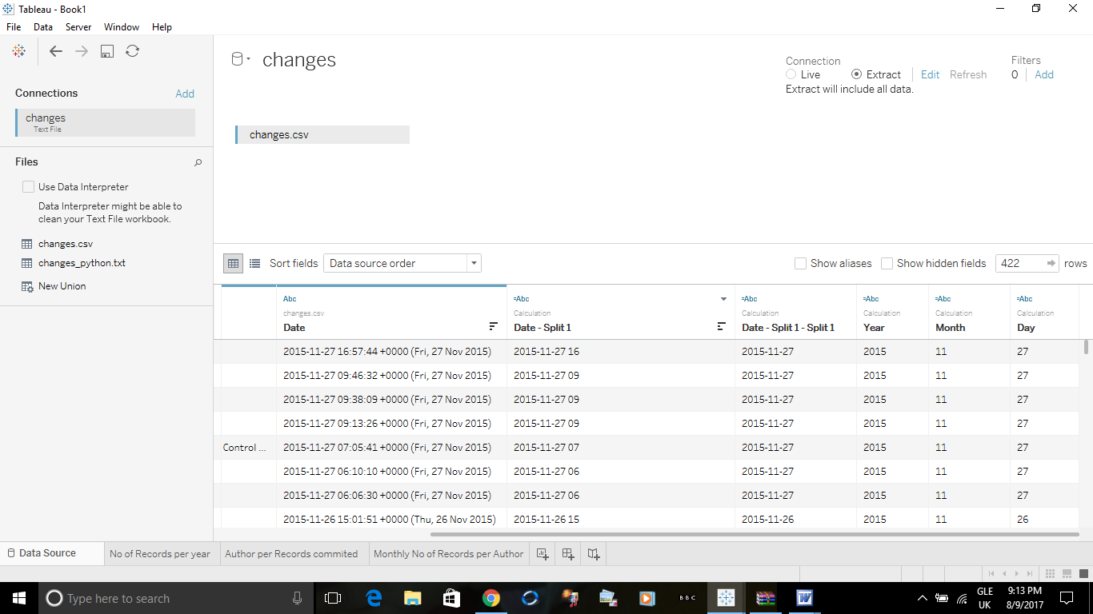
Fig.1

2. Fig.2 shows the number of commits each Author made per year. The bigger the circle/ball the higher the number of commits. The Author with the smallest circle/ball has the least commits for that particular year.
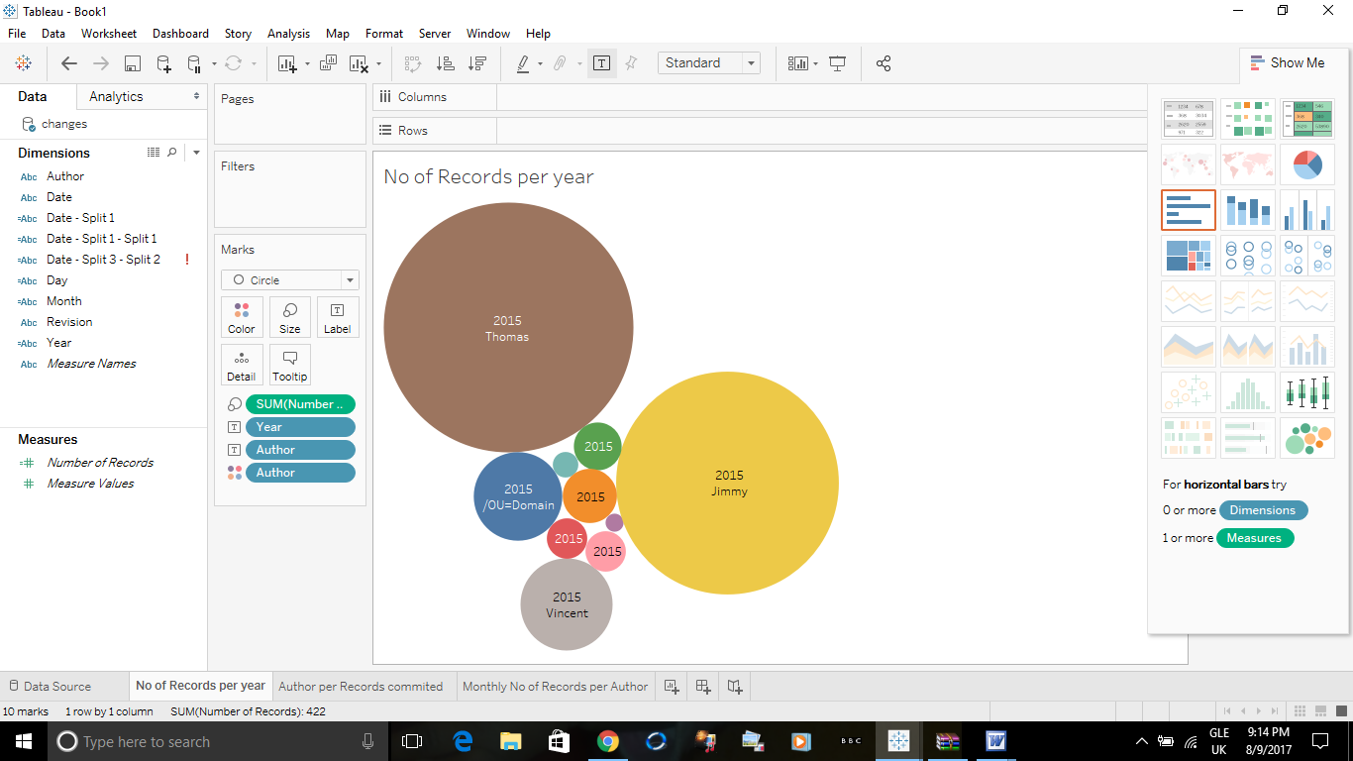
Fig.2

Fig.3 shows Author per total number of commits using a bar chart.

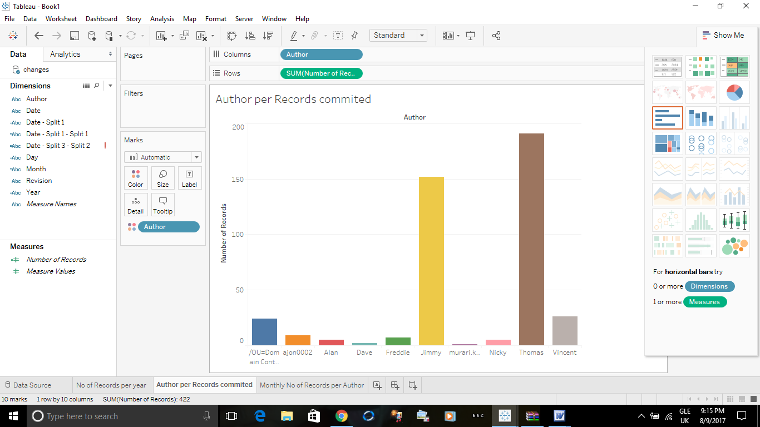
Fig.3

Fig.4 shows Each Author’s monthly number of commits.

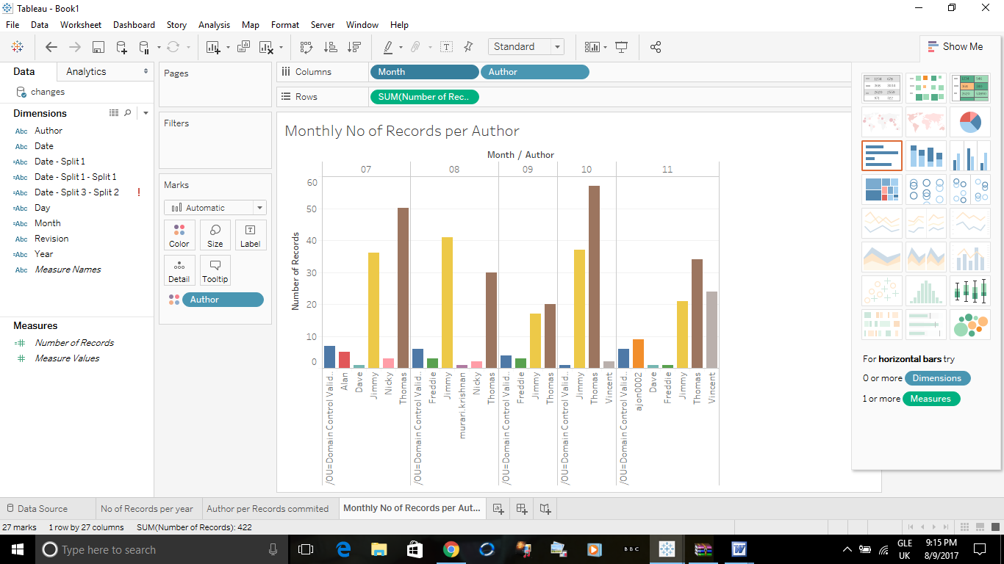
Fig.4

CONCLUSION: In conclusion, looking at the number of records for each Author, it could be seen that Thomas has the highest number of commits. Thomas commits highest in all the months analyzed except in August where he came second to Jimmy.
It could also be seen that not all Author commits every month. It was only Thomas and Jimmy Number of records recorded for every month. Vincent who only has two recorded commits overall has a 1100% increase in the number of records from October to November.

Analysis of the dataset produced a substantial amount of information that is very crucial to the growth of any organisation. Information about a staff who is redundant could be obtained from the number of commits the staff makes. Also, organisations could see and compare productivity for each month.

